Karina Sirabian 8/28/20

ENVST206 Activity 1

1. For every file or folder on a computer, it’s path is unique because the path describes the location of the file (or folder) on the computer. For example, the folder path /Users/russell/GitHub/ENVST_206 describes where my folder for this class (ENVST_206) is located on my computer. By looking at this folder path, we know that ENVST_206 is in the GitHub folder. If we look at the file path for the R script we created in class for activity 1 (/Users/russell/GitHub/ENVST_206/Activity1.R) we know that the script is located in the ENVST_206 folder. File paths are different than folder paths because once you reach a file, that path cannot continue any further. Additionally with file paths, at the end of the file name, the type of file is showed (here it says .R because Activity1 is a R file). Lastly, the file path for this document is /Users/russell/Desktop/Activity1.docx which tells us that this document is located on the desktop and the file type is a word document.
2. To commit an edit to your script, first save it and then go to the terminal. Once you are in the directory of your repository folder, you need to enter 3 commands into the terminal. First type the command “git add –A” to add changed to all files for tracking. Next type the command “git commit –m “description of changes”” (where description of changes can be anything you want to write). This command helps label all your changes in your repository on github. Lastly, type the command (“git push”), which sends the changes to github.

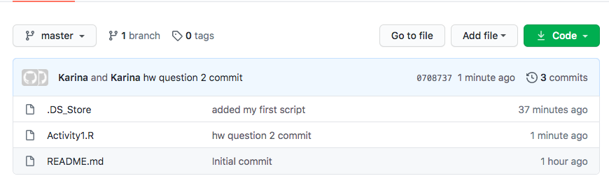

3/4. <https://github.com/Karina-Sirabian/ENVST_206.git>